**GIT TO BIT BUCKET**

**Prerequisite:**

1. Request at self-service portal to create new Project for SDS on bit bucket .
2. Request at self-service portal to create new repository for SDS on BIT BUCKET
3. Third party tool (Source Tree/ Git Ext.) to manage the repository.
4. Prepare existing solution to migrate on Bit bucket
5. Remove all unnecessary binaries
6. Use nuget package for all dependencies if possible
7. Add gitignore file

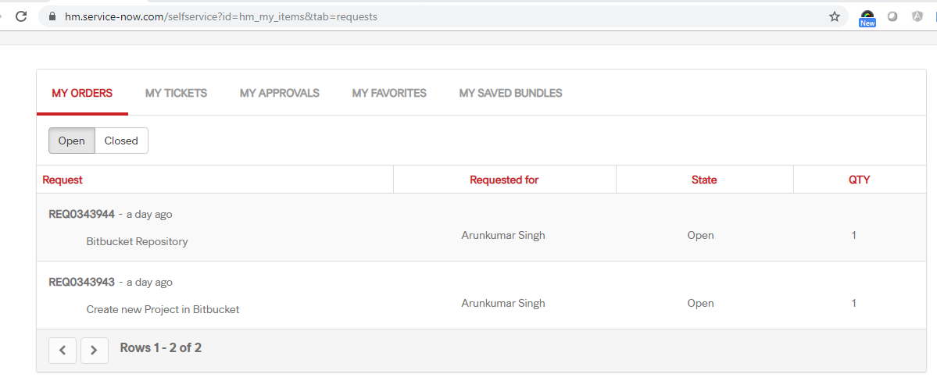

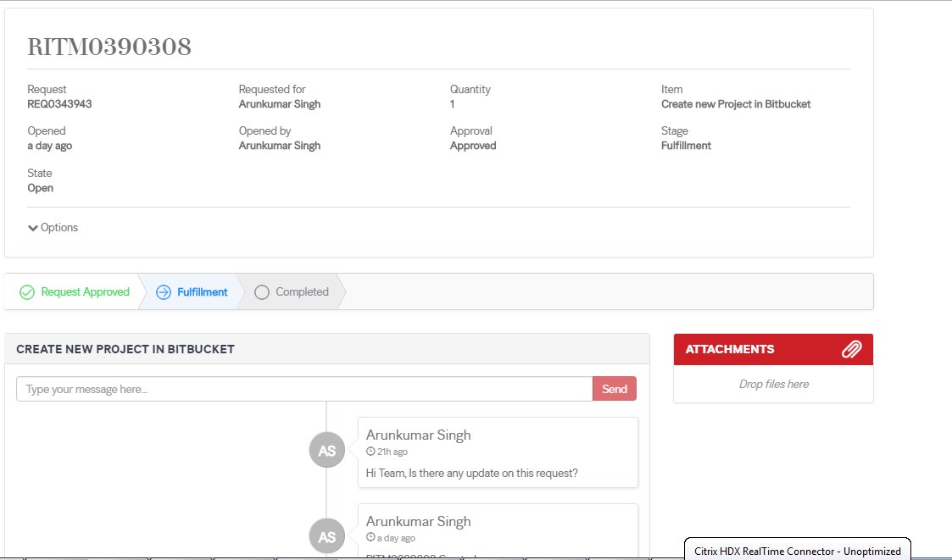

# Importing code from an existing project

Import code using the web interface

Introduced in [Bitbucket Server 4.9](https://confluence.atlassian.com/bitbucketserver/bitbucket-server-4-9-release-notes-838535696.html), you can import code and its version/branching history into Bitbucket Server from existing Git projects hosted with Bitbucket Cloud, GitHub, GitHub Enterprise, or a standalone Git repository using the web interface.

**To start importing code**

1. While viewing a project within Bitbucket Server click **Import repository** in the sidebar.
2. Select a source to import code from, provide the required information, then click **Connect**.
   1. **For Bitbucket Cloud**, include the Username and [App password](https://bitbucket.org/account/admin/app-passwords) for the account to import from, and ensure read access for team, project, and repository is enabled.
   2. **For GitHub**, include the Username and [Personal access token](https://github.com/settings/tokens) for the account to import from, and ensure the **repo** and **read:org** [scopes](https://developer.github.com/v3/oauth/#scopes) are enabled.
   3. **For GitHub Enterprise**, provide the Server URL, Username, and [Personal access token](https://github.com/settings/tokens) for the account to import from, and ensure the **repo** and **read:org** [scopes](https://developer.github.com/v3/oauth/#scopes) are enabled.
   4. **For a single Git repository**, provide the Clone URL, and Username and Password (if required).
3. Choose which repositories to import.
   1. **All repositories** imports all the repositories owned by the account provided.
   2. **Select repositories** allows you choose specific repositories to import.
4. Click **Import**.

Once importing completes, you can refresh the project page to see the imported repositories.

**Import code using the terminal**

Import code from an existing project using the terminal by first cloning the repository to your local system and then pushing to an empty Bitbucket Server repository.

**Import an existing, unversioned code project into Bitbucket Server**

If you have code on your local machine that is not under source control, you can put it under source control and import it into Bitbucket Server.

Assuming you have Git installed on your local machine, then:

1. Locally, change to the root directory of your existing source.
2. [Initialize the project](https://www.atlassian.com/git/tutorials/setting-up-a-repository/git-init) by running the following commands in the terminal:
3. git init
4. git add --all

git commit -m "Initial Commit"

1. Log into Bitbucket Server and [create a new repository](https://confluence.atlassian.com/bitbucketserver/creating-repositories-776639815.html).
2. Locate the clone URL in the nav panel on the left (for example: *https://username@your.bitbucket.domain:7999 /yourproject/repo.git*).
3. Push your files to the repository by running the following commands in the terminal (change the URL accordingly):
4. git remote add origin https://username@your.bitbucket.domain:7999/yourproject/repo.git

git push -u origin master

1. Done! Your repository is now available in Bitbucket Server.

**Import an existing Git project into Bitbucket Server**

You can import your existing Git repository into an empty repository in Bitbucket Server. When you do this, Bitbucket Server maintains your commit history.

1. [Check out the repository from your existing Git host](https://www.atlassian.com/git/tutorials/setting-up-a-repository/git-clone). Use the *--bare*parameter:

git clone --bare https://username@bitbucket.org/exampleuser/old-repository.git

1. Log into Bitbucket Server and [create a new repository](https://confluence.atlassian.com/bitbucketserver/creating-repositories-776639815.html) (we've called it repo.git in this example).
2. Locate the clone URL in the nav panel on the left (for example: *https://username@your.bitbucket.domain:7999 /yourproject/repo.git*).
3. Add Bitbucket Server as another remote in your local repository:
4. cd old-repository

git remote add bitbucket https://username@your.bitbucket.domain:7999/yourproject/repo.git

1. Push all branches and tags to the new repository in Bitbucket Server:
2. git push --all bitbucket

git push --tags bitbucket

1. Remove your temporary local repository:
2. cd ..

rm -rf old-repository

**Mirror an existing Git repository**

You can mirror an existing repository into a repository hosted in Bitbucket Server.

1. Check out the repository from your existing Git host. Use the *--mirror*parameter:

git clone --mirror https://username@bitbucket.org/exampleuser/repository-to-mirror.git

1. Log into Bitbucket Server and [create a new repository](https://confluence.atlassian.com/bitbucketserver/creating-repositories-776639815.html) (we've called it repo.git in this example).
2. Locate the clone URL in the nav panel on the left (for example: https://username@your.bitbucket.domain:7999 /yourproject/repo.git).
3. Add Bitbucket Server as another remote in your local repository:

git remote add bitbucket https://username@your.bitbucket.domain:7999/yourproject/repo.git

1. Then push all branches and tags to Bitbucket Server:
2. git push --all bitbucket

git push --tags bitbucket

1. Use [git fetch --prune origin](https://www.atlassian.com/git/tutorials/syncing#git-fetch)  ('–prune' will remove any branches that no longer exist in the remote) followed by the [git push](https://www.atlassian.com/git/tutorials/syncing#git-push) commands from step 5 to update the Bitbucket Server mirror with new changes from the upstream repository.

**Some other way to do with UI**

**Final working solution**

1. Suppose you have your project folder on PC;
2. Create a new repository on bitbucket: [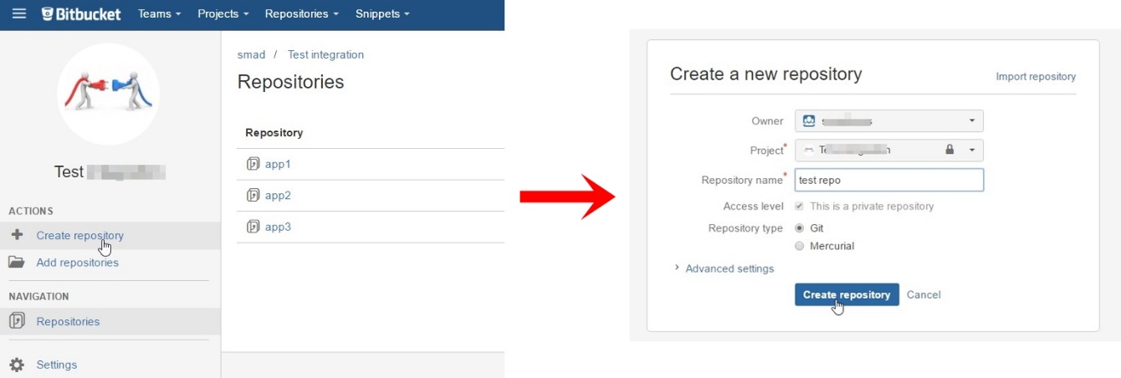](https://i.stack.imgur.com/yOLBC.jpg)
3. Press on *I have an existing project*: [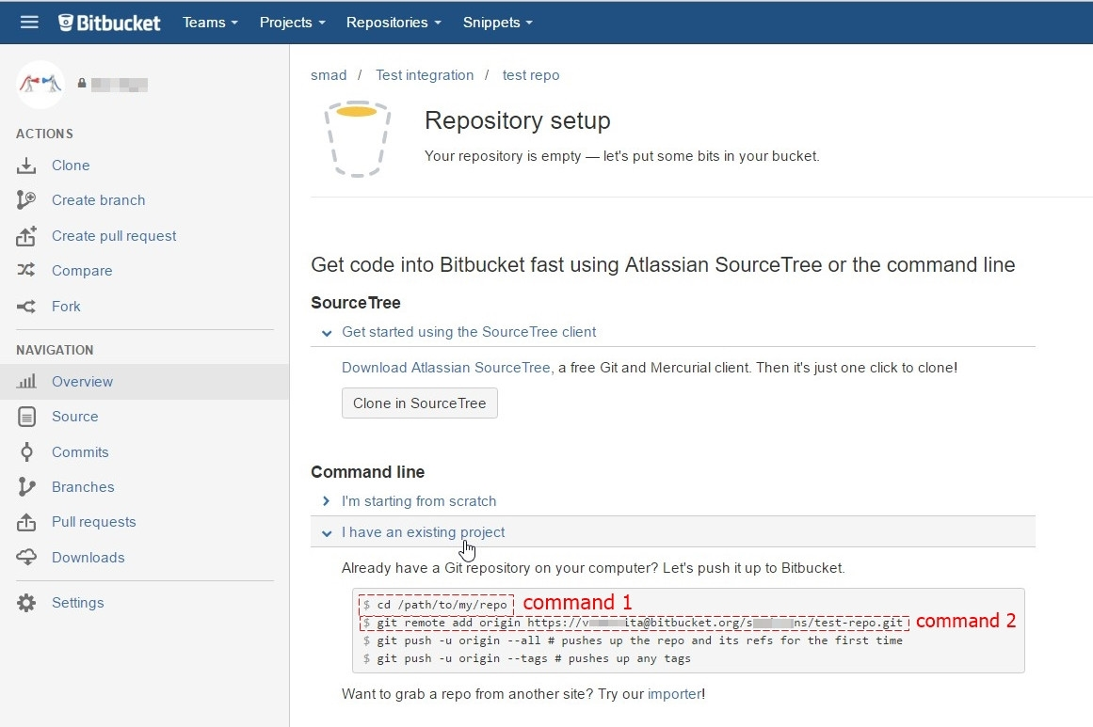](https://i.stack.imgur.com/4tj5n.jpg)
4. Open Git CMD console and type command 1 from second picture(go to your project folder on your PC)
5. Type command git init
6. Type command git add --all
7. Type command 2 from second picture (git remote add origin YOUR_LINK_TO_REPO)
8. Type command git commit -m "my first commit"
9. Type command git push -u origin master

Note: if you get error unable to detect email or name, just type following commands after 5th step:

git config --global user.email "yourEmail" #your email at Bitbucket

git config --global user.name "yourName" #your name at Bitbucket

**How did we transfer to Bitbucket?**

Bitbucket makes it extremely easy to transfer your repos from GitHub. Here are the steps on how to do so:

1. Backup your GitHub repo

githubzip

The first thing we did was backup our repos in case something bad happened in the transfer. To do so, you can simply go to your repo and click the Download ZIP button.

2. Copy your HTTPS clone URL

githubhttps

We chose to transfer via the HTTP clone URL. The clone URL can be found right next to the Download ZIP button that you just clicked (there is even a nice copy-to-clipboard button).

3. Import your repo into Bitbucket



Next, you will want to log into your Bitbucket account and create a repository. Then, instead of filling out the required information, you can import a repository by clicking the link in the top right corner (or https://bitbucket.org/repo/import if you are logged in).

4. Fill out the information required

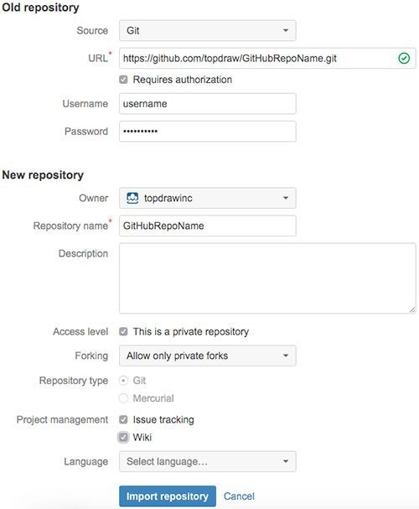

Fill out the required information from Bitbucket and click the “Import Repository” button.

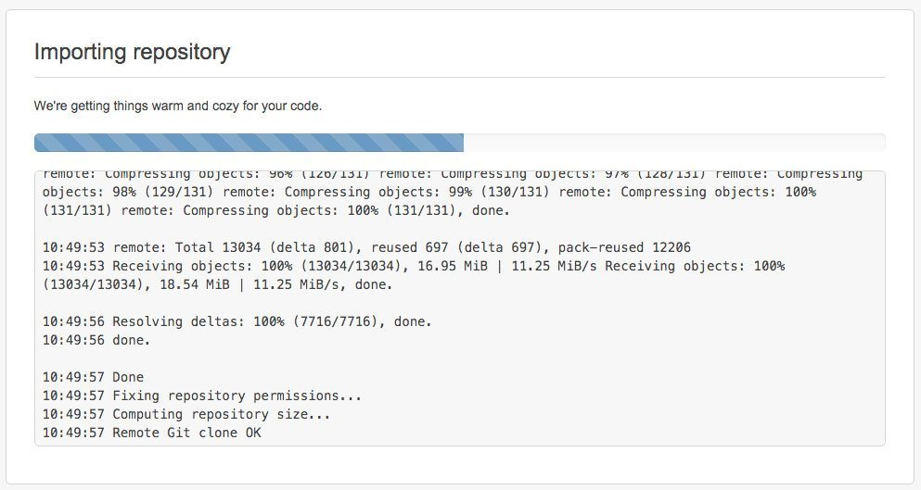

*Note: If your authorization credentials are wrong, you may get an error. Simply click back, fill out the information correctly and import again.*

And that’s all folks!

Just like that, we have now imported our GitHub repo into our BitBucket account.

**Teamcity integration**

Need to change the VCS path in teamcity

